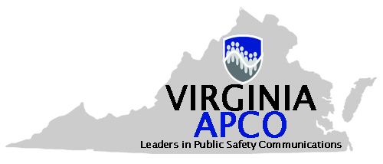

APCO VIRGINIA CHAPTER COMMITTEE REQUEST

CHECK THE COMMITTEE(S) YOU ARE INTERESTED IN

STANDING COMMITTEES

9-1-1 COMMITTEE

AWARDS COMMITTEE

BY-LAWS/POLICY COMMITTEE

NOMINATIONG COMMITTEE

HISTORICAL COMMITTEE

MEMBERSHIP COMMITTEE

CONFERENCE COMMITTEE

PROCHART COMMITTEE

LEGISLATIVE COMMITTEE

TRAINING/SCHOLARSHIP COMMITTEE

SUNSHINE FUND SPECIAL REVIEW COMMITTEE

EMERGING TECHNOLOGIES COMMITTEE

WEBMASTER/LISTSERV ADMIN

SPECIAL COMMITTEES

COMMERCIAL ADVISORY COMMTTEE

MEMBER AND CHAPTER SERVICES COMMITTEE

EMERGING LEADERS COMMITTE

CONFERENCE COMMITTEE – Function(s) Preferred: ____________________________ _

______________________________________________________________________________

Name: ________________________________________________________________________

Agency: ________________________________________________________________________

Phone: ________________________________________________________________________

E-Mail: ________________________________________________________________________

Special Qualifications: ___________________________________________________________________

______________________________________________________________________________________

